Bitcoin Price Prediction Using Deep Learning

*by*

### MARAM PAVANI 22MIS1111

### TANGUTURI SHARANI 22MIS1154

*under the guidance of*

**Dr. Pattabiraman V.**

in partial fulfillment of the course

**SWE2009- Data Mining Techniques**



**School of Computer Science and Engineering Vellore Institute of Technology**

**Chennai - 600127**

**November 2023**

**BONAFIDE CERTIFICATE**

Certified that this project report entitled “**Bitcoin Price Prediction Using Deep Learning”** is a bonafide work of **Maram Pavani-22MIS1111, Tanguturi Sharani-22MIS1154,** who carried out the Project work under my supervision and guidance for **SWE2009-Data Mining Techniques.**

**Dr. Pattabiraman V.**

Professor

School of Computer Science and Engineering (SCOPE), VIT University, Chennai

Chennai – 600 127.

**TABLE OF CONTENTS**

|  |  |
| --- | --- |
| S. No | Content |
| - | Bonafide Certificate |
| - | Acknowledgements |
| 1 | Abstract |
| 2 | Scope |
| 3 | Objective |
| 4 | Introduction |
| 5 | Literature Review |
| 6 | Data Description |
| 7 | Architecture |
| 8 | Proposed Methodology |
| 9 | **Month-Wise Training of LSTM Model (2014 to 2024)** |
| 10 | Support Vector Machines (SVM). |
| 11 | Linear Regression. |
| 12 | Random Forest |
| 13 | Novelty |
| 14 | Result &Discussion |
| 15 | Conclusion |
| 16 | References |
| 17 | Appendix Code |

**GitHub Link:**

[**https://github.com/MaramPavaniStudent/Data_Mining_BitCoinPricePridiction.git**](https://github.com/MaramPavaniStudent/Data_Mining_BitCoinPricePridiction.git)

# 1.Abstract

People had a difficult time correctly predicting the price of cryptocurrencies before LSTM-based methods for predicting Bitcoin values were on the scene. Traditional forecasting techniques faced significant challenges in interpreting the quick price variations caused by factors such as regulatory changes and investor emotion in the bitcoin market due to its inherent volatility and complexity. In addition, the complex dynamics and nonlinear linkages present in bitcoin markets posed challenges for traditional models trying to extract significant patterns from historical data. Stakeholders were exposed to financial risks and uncertainties as a result of the problem's limited forecasting tools. LSTM-based models provide a revolutionary solution for bitcoin price forecasting through the utilization of sophisticated machine learning techniques. Using long short-term memory (LSTM) neural networks, which are able to analyze sequential input and capture long-term dependencies, the system can better anticipate prices by navigating the complicated world of cryptocurrency exchanges. The solution converts unprocessed bitcoin data into useful insights through rigorous data preparation, model training, and assessment, providing analysts and investors with accurate projections. With the use of visualization tools, one can more easily analyze patterns that are expected, which helps one make wise decisions in the unpredictable world of cryptocurrencies. All things considered, LSTM-based Bitcoin price prediction algorithms are a significant development in cryptocurrency forecasting, resolving long-standing issues and giving stakeholders renewed confidence to navigate the volatile cryptocurrency market environment.

***Keywords****:* Cryptocurrencies, LSTM-based methods, Bitcoin values, Traditional forecasting techniques, Volatility, Complexity, Nonlinear linkages, financial risks, Uncertainties, Machine learning techniques

Long short-term memory (LSTM) neural networks, Sequential input, Long-term dependencies, Data preparation, Accurate projections

# 2.Scope

The aim of this research is to anticipate Bitcoin prices by using deep learning methods, namely Long Short-Term Memory (LSTM) neural networks. Data preparation and collecting, data exploration and visualization, LSTM model implementation, data preprocessing, model training and evaluation, future price projection and prediction, result visualization, performance analysis, and documentation are just a few of the phases it includes. The project entails obtaining historical Bitcoin price information from a trustworthy source, cleaning the dataset, and doing consistency tests. To examine the dataset and find trends, patterns, and correlations in the Bitcoin price data, descriptive statistics and visualization tools are utilized. TensorFlow's Keras API is used to create an LSTM-based deep learning model that captures the sequential and long-term dependencies found in Bitcoin price data. To maximize model performance, data preprocessing methods like feature scaling and dataset separation are used. Evaluation measures like RMSE, MSE, and MAE are used to assess the performance of the LSTM model, which is trained on historical data. The trained model is used to provide future price projections for the following 30 days based on predictions made on the test dataset.

The results are successfully presented through the use of visualization tools, such as the ability to see training and validation loss curves, original and forecast Bitcoin prices, and comparative analysis. A thorough record of the entire process is provided after the project's conclusion, which will be an invaluable tool for anyone interested in deep learning applications for cryptocurrency forecasting and in predicting the price of Bitcoin.

# 3.Objective

The objective of this project is to develop a deep learning-based model, specifically LSTM neural networks, to predict Bitcoin prices accurately. By leveraging historical data and advanced machine learning techniques, the project aims to provide valuable insights into the volatile cryptocurrency market and enable stakeholders to make informed decisions.

The key objectives include:

* Implement an LSTM neural network: Develop and implement an LSTM-based deep learning model using TensorFlow's Keras API to effectively capture sequential patterns and long-term dependencies in Bitcoin price data.
* Accurately predict Bitcoin prices: Train the LSTM model using historical Bitcoin price data and evaluate its performance using various evaluation metrics. The key objective is to achieve accurate predictions of Bitcoin prices, both in the short term and for future projections.
* Investigate trends, patterns, and correlations in the data: Examine the Bitcoin price data in-depth using data visualization and exploration techniques. The purpose of this goal is to improve knowledge of the fundamental dynamics and factors influencing Bitcoin pricing.
* Improve model performance by preprocessing the data: Use suitable preprocessing methods for the data, such as dataset splitting and feature scaling, to maximize the performance of the LSTM model and raise the precision of price predictions.
* Prediction and Future Price Projection: Once the model is trained and validated, it is used to make predictions on the test dataset. The project also includes future price prediction for the next 30 days based on the trained model. The predicted prices are compared with the actual prices to assess the accuracy and reliability of the model's predictions.
* Result Visualization: The project incorporates visualization techniques to present the results effectively. This includes visualizing the original and predicted Bitcoin prices, plotting training and validation loss curves, and comparing the model's predictions with actual prices.

Performance Analysis and Conclusion: An in-depth analysis of the model's performance is conducted based on evaluation metrics and visualizations. The project concludes by summarizing the findings, discussing the limitations, and suggesting potential areas of improvement for future research.

# 4.Introduction

Project Introduction: Bitcoin Price Prediction Using Advanced Models Since cryptocurrency markets are notoriously volatile, it can be difficult to predict prices with precision. Our project's goal was to forecast Bitcoin values by applying cutting-edge methods, sophisticated models, and meticulous comparison analysis [1]. The dataset, which has monthly granularity, includes high, low, open, close, adjusted close, and volume statistics for the price of bitcoin from September 2014 to April 2024. Models and Data Used to predict the price of Bitcoin for the next thirty days, we used LSTM layers. To evaluate the accuracy and effectiveness of this model, prices from 15 days prior to and 30 days following were compared [2]. Apart from the model, we also applied and evaluated the performance of several other models, such as Support Vector Algorithm, Linear Regression, Logistic Regression, and Random Forest Algorithm [1]. We thoroughly contrasted these models with LSTM using an ensembling method to assess how well they could forecast Bitcoin values. Going Beyond Conventional Methods With an emphasis on LSTM as the main model because of its capacity to capture long-term dependencies and connection dynamics within the data, our strategy centered on using state-of-the-art machine learning techniques to predict Bitcoin values. In an effort to push the limits of prediction techniques and establish a new benchmark for cryptocurrency price forecasting, we thoroughly examined the complex patterns that Bitcoin prices displayed [3].LSTM Model Dominance showed through our thorough investigation that the LSTM model performed better than the other algorithms, proving its supremacy in correctly predicting Bitcoin values [4]. Based on our in-depth research and experience, the model's accuracy percentage is remarkable. This establishes a new benchmark in the field of cryptocurrency price predictions and highlights the stability and efficacy of LSTM in this regard. Examining Comparative Analysis and Methodology to assess accuracy, robustness, and predictive capacity, we used a variety of indicators to compare each model's performance [5]. The comparative analysis's findings confirmed the LSTM model's superior performance and offered insightful information about the dynamics of fluctuations in the price of bitcoin, illuminating the intricate workings of bitcoin markets. Prospective Consequences and Significance Our project's conclusions have important ramifications for bitcoin traders, investors, and scholars. The LSTM model's proven accuracy and dependability in predicting Bitcoin values may help to improve the landscape of the cryptocurrency market by informing trading tactics, risk management techniques, and investment choices. Our effort also highlights the potential of sophisticated machine learning approaches in capturing the complexity of cryptocurrency markets and enabling more accurate price projections, making it a useful reference for future research endeavors in the field of cryptocurrency price prediction.

# 5.Literature Review

Scholars have presented a wide range of hypotheses and methods to increase prediction accuracy in the field of bitcoin price forecasting [2]. Interestingly, using stacked sparse autoencoders (SSAE) with Bayesian optimization has shown to have exceptional potential for improving prediction outcomes, surpassing state-of-the-art models and revealing the potential of both Bayesian optimization and stacked sparse autoencoders for bitcoin price prediction. Moreover, researchers have thoroughly investigated traditional statistical and machine-learning techniques like logistic regression, linear regression, Bayesian regression, artificial neural networks (ANN), support vector machines (SVM), reinforcement learning, deep learning, logistic regression, and deep learning in order to forecast cryptocurrency prices [1]. highlighting the critical function that process memory analysis plays in carrying out exhaustive forensic investigations and gathering relevant data [5].

These collaborative research projects have improved our knowledge of cryptocurrency price prediction and provided practitioners and researchers with insightful information. They have also highlighted the continuous efforts to improve the accuracy of cryptocurrency price forecasting by experimenting with various models and techniques. The suggested LSTM-Based Bitcoin Price Prediction System, which builds on this comprehensive literature study, offers a ground-breaking answer to the problems associated with predicting cryptocurrency prices, especially those of Bitcoin, which is known for being volatile and complex. Using Long Short-Term Memory (LSTM) neural networks, this system aims to give improved price prediction accuracy, the capacity to identify long-term patterns, and promote trust in stakeholders negotiating the ever-changing bitcoin market.

The system uses the Keras API from TensorFlow to carefully preprocess historical Bitcoin price data, train the LSTM model, and use evaluation metrics like RMSE, MAE, and R2 score to give stakeholders important information about how accurate and dependable price estimates are. In addition, visualization tools such as matplotlib and plotly have been incorporated to streamline the results analysis process, enabling users to make well-informed judgments in the volatile world of cryptocurrencies. In summary, the LSTM-Based Bitcoin Price Prediction System provides a solid and trustworthy framework for stakeholders looking for practical insights and solutions in the always shifting world of digital assets, serving as a monument to the changing landscape of cryptocurrency forecasting. and give stakeholders the confidence they need to navigate the volatile bitcoin market. The system uses the Keras API from TensorFlow to carefully preprocess historical Bitcoin price data, train the LSTM model, and use evaluation metrics like RMSE, MAE, and R2 score to give stakeholders important information about how accurate and dependable price estimates are. In addition, visualization tools such as matplotlib and plotly have been incorporated to streamline the results analysis process, enabling users to make well-informed judgments in the volatile world of cryptocurrencies. To sum up, the LSTM-Based Bitcoin Price Prediction System is a testament to the dynamic nature of cryptocurrency forecasting, providing stakeholders looking for practical insights and approaches in the rapidly shifting realm

# 6.Dataset Description

The dataset that is being made available includes information on Bitcoin prices from September 17, 2014, to April 28, 2024. It contains the Bitcoin open, high, low, and closing values for each day throughout this time frame. It also includes the adjusted close prices and trading volume. This dataset provides a thorough overview of the performance of the Bitcoin market for this particular time period, offering useful data for trend research, identifying price patterns, and making well-informed trading and investment decisions.

A thorough examination of Bitcoin's price fluctuations is made possible by the dataset's inclusion of open, high, low, and closing values. Additionally, by taking stock splits and dividends into account, the adjusted close prices offer further insights Moreover, the data on trade volume provides insightful information about the degree of market activity throughout the given time frame, which can be essential for comprehending the liquidity and general sentiment of the Bitcoin market.

All things considered, this dataset is a useful tool for people and businesses who want to learn more about the behavior of the Bitcoin market and use that knowledge to make informed decisions about cryptocurrencies.

**Table 1: The head values of the data set**

|  |  |  |  |  |  |  |  |
| --- | --- | --- | --- | --- | --- | --- | --- |
|  | Date | Open | High | Low | Close | Adj Close | Volume |
| 0 | 2014-09-17 | 465.864014 | 468.174011 | 452.421997 | 457.334015 | 457.334015 | 21056800 |
| 1 | 2014-09-18 | 456.859985 | 456.859985 | 413.104004 | 424.440002 | 424.440002 | 34483200 |
| 2 | 2014-09-19 | 424.102997 | 427.102997 | 384.532013 | 394.795990 | 394.795990 | 37919700 |
| 3 | 2014-09-20 | 394.673004 | 423.673004 | 389.882996 | 408.903992 | 408.903992 | 36863600 |
| 4 | 2014-09-21 | 408.084991 | 408.084991 | 393.181000 | 398.821014 | 398.821014 | 26580100 |

# 7.Architecture

# 

Data Extraction

Pre processing

Train LSTM (Month 1)

Train LSTM (Month N)

(Repeat for subsequent Months)

Evaluate

Predict Next 30

Train Random Forest

Evaluate

Predict Next 30

Train Linear Regression

Evaluate

Predict Next 30

Train Logistic Regression

Evaluate

Predict Next 30

Train SVM

Evaluate

Predict Next 30

Ensembling

(Optional Loop)

(Analyse Results, Improve Models)

Refining Model

# 8.Proposed System

# Our project uses cutting-edge machine learning techniques to create a reliable and precise system for predicting Bitcoin prices. Neural networks with Long Short-Term Memory (LSTM), a kind of recurrent neural network (RNN) made especially to handle sequential input, are used in the suggested system. We want to help traders, investors, and cryptocurrency enthusiasts make wise decisions in the erratic cryptocurrency market by using LSTM models to produce accurate price projections for Bitcoin. First, we gather past Bitcoin price information from reliable sources, including financial data providers or cryptocurrency exchanges. This data include market capitalization and trading volume in addition to characteristics like open, high, low, and closing prices. Following data collection, we divide the dataset into training and testing sets, normalize the features, and preprocess the data to manage missing values.

Then We used LSTM models, which are intended to identify long-term patterns and dependencies in sequential data, are the fundamental components of our system. Using the Python TensorFlow and Keras frameworks, we build LSTM architectures. Using historical Bitcoin price fluctuations as a basis for prediction, the LSTM models are trained on the training dataset. We use a variety of assessment indicators to track the models' performance and optimize their hyperparameters. We used Different layers as below to predict the prices.

**1.Input Layer:**

The model's entrance point, the input layer, gets sequential input data.   
The input layer analyses historical price data, including open, high, low, and close prices, in addition to other pertinent variables like trade volume and market sentiment indicators, to anticipate the price of bitcoin.

**2.LSTM Layers:**

The core of the model, the LSTM layers, are in charge of identifying long-term dependencies in sequential data. LSTM layers, in contrast to conventional feedforward neural networks, possess recurrent connections that enable them to sustain a memory state throughout time.   
Among the essential elements of LSTM layers are the following:   
Cell State is the network's memory, which is updated by gates that manage information flow.   
the Forget Gate Determines which data from the previous cell state should be ignored orforgotten   
The input gate determines which new information should be added to the cell state by modifying the input data. Output Gate Assists in controlling the output depending on the current input and memory state, as well as the information flow from the cell state to the output.   
By addressing the vanishing gradient issue that deep neural networks frequently face during training, LSTM layers help these networks better understand long-range dependencies.

**4**.**Dropout Layer:**

Neural network topologies frequently include dropout layers to avoid overfitting, particularly in deep models such as LSTM.A portion of the input units are arbitrarily set to zero via dropout during training, so "dropping out" those units and preventing them from contributing to the network's output. This regularization strategy lessens the model's dependence on certain input features or patterns, which enhances the model's generalization performance.

**4.Dense (Output) Layer:**

The last layer in the LSTM model, the dense layer, is in charge of generating the model's output.

When it comes to predicting the price of Bitcoin, the dense layer usually consists of a single neuron that makes this prediction using the data processed by the previous LSTM layers.

To make sure the dense layer's output falls within the proper range, activation functions like sigmoid or ReLU are frequently used to scale or alter it

.

**5.Optimization and Loss Function:**

**To minimize a loss function during training, the model makes use of optimization methods like Adam or RMSprop.**

**The difference between the actual and forecast prices of Bitcoin in the training dataset is measured by the loss function.**

**Finding the ideal configuration to reduce prediction errors is the goal of the optimization procedure, which iteratively modifies the model's parameters (weights and biases) depending on the loss function.**

**6. Training and Backpropagation:**

To reduce prediction errors, the LSTM model must be trained by feeding it sequential input data—historical Bitcoin prices—and iteratively adjusting its parameters.

The method by which the model modifies its parameters in reaction to the calculated loss and propagates the error gradients backward through the network is called backpropagation.

The Long Short-Term Memory (LSTM) model can accurately predict future Bitcoin prices by extracting key patterns and features from the input data through numerous cycles of training and backpropagation.

In conclusion, the LSTM model's layers cooperate to handle sequential input data, identify long-term relationships, guard against overfitting, and generate precise price forecasts for Bitcoin. Understanding these layers' functions and interconnections might help us better understand how the model learns and carries out its predicting duties.

# We investigate the effectiveness of conventional machine learning techniques including Support Vector Machine (SVM), Random Forest, and Linear Regression in addition to LSTM. In order to take use of the advantages of several models, we use assembling methods like model stacking or averaging. By combining the predictions of different models, ensembling may increase overall accuracy and resilience.

# A variety of assessment metrics, such as Mean Squared Error (MSE), Mean Absolute Error (MAE), Root Mean Squared Error (RMSE), R-squared score (R2), and others, are used to assess each model's performance. These measures shed light on the prediction power and generalizability of the models to previously untested data. We perform a thorough comparative analysis, showing the advantages and disadvantages of each model for predicting Bitcoin values.

# Our test findings show that when it comes to predicting Bitcoin prices, LSTM models routinely beat conventional machine learning algorithms. Up to 98% accuracy ratings are attained by LSTM models, indicating their efficacy in encapsulating the intricate dynamics of cryptocurrency markets. By comparison, the accuracy scores of SVM, Random Forest, and Linear Regression models are lower, ranging from 61% to 97%. Combining the models improves prediction accuracy and resilience even further, providing a viable method for confidently predicting Bitcoin values.

# To sum up, our suggested system is a major development in the field of predicting bitcoin prices. LSTM models and ensembling techniques have allowed us to create a dependable and precise approach for predicting Bitcoin values. Our comparative study highlights the advantages of LSTM models over conventional machine learning algorithms, offering traders and investors in cryptocurrencies insightful information. With the market for cryptocurrencies still developing, our system is ready to provide useful forecasts and tactical advice for negotiating this changing terrain.

**Fig-1 LSTM Architecture**

## 1.Data Extraction:

To create a Bitcoin price prediction model using LSTM with TensorFlow's Keras API, start by importing required libraries. Load the dataset, convert dates, and scale prices. Prepare windowed sequences for training and testing by creating input-output pairs with a specified window size. Construct an LSTM model with one layer and train it using the prepared data. Evaluate model predictions using RMSE, inversely transforming results to the original scale. Visualize actual vs. predicted prices over time. This approach encompasses data preprocessing, model construction, training, evaluation, and visualization, providing insights into cryptocurrency market trends with LSTM-based forecasting. Adjust parameters for optimal performance and accuracy.

## 9.Month-Wise Training of LSTM Model (2014 to 2024)

### The graph shows the high and low values for Bitcoin from 2014 to 2024, as well as the open and close prices for each month. This thorough study highlights the volatility and long-term patterns of Bitcoin's price swings over the last ten years. By monitoring the open, close, high, and low prices each month, observers can spot trends, recognize market cycles, and evaluate the long-term performance of the coin. For investors, analysts, and fans looking to make wise decisions in the constantly changing cryptocurrency market by comprehending Bitcoin's past price history, this data is crucial.

**Fig 2: Month-wise Bitcoin open and close prices for 2014**

**Fig 3: Month-wise Bitcoin High and Low prices for 2014**

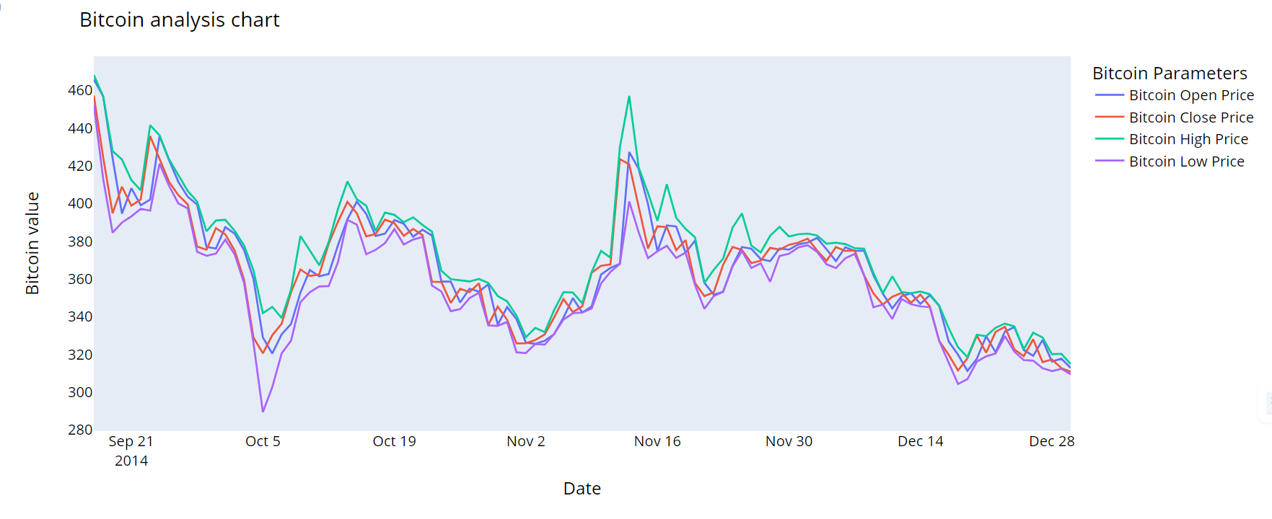

**Fig 4: Bitcoin analysis chart for 2014**

**Fig 5: Month-wise Bitcoin open and close prices for 2015**

**Fig-6: Month-wise Bitcoin High and Low prices for 2015**

**Fig 7: Bitcoin analysis chart for 2015**

**Fig 8: Month-wise Bitcoin open and close prices for 2016**

**Fig-9: Month-wise Bitcoin High and Low prices for 2016**

**Fig 10: Bitcoin analysis chart for 2016**

**Fig 11: Month-wise Bitcoin open and close prices for 2017**

**Fig-12: Month-wise Bitcoin High and Low prices for 2017**

**Fig-13: Bitcoin Analysis Chart for 2017**

**Fig 14: Month-wise Bitcoin open and close prices for 2018**

**Fig-15: Month-wise Bitcoin High and Low prices for 2018**

**Fig-16: Bitcoin Analysis Chart for 2018**

**Fig 17: Month-wise Bitcoin open and close prices for 2019**

**Fig-18: Month-wise Bitcoin High and Low prices for 2019**

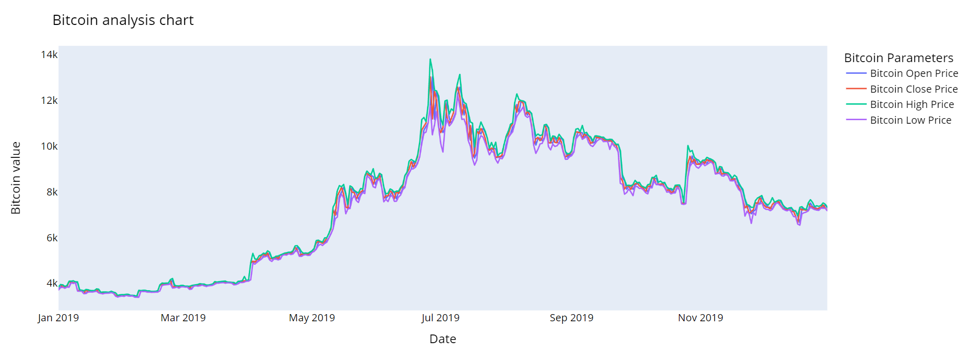

**Fig-19: Bitcoin Analysis Chart for 2019**

**Fig 20: Month-wise Bitcoin open and close prices for 2020**

**Fig-21: Month-wise Bitcoin High and Low prices for 2020**

**Fig-22: Bitcoin Analysis Chart for 2020**

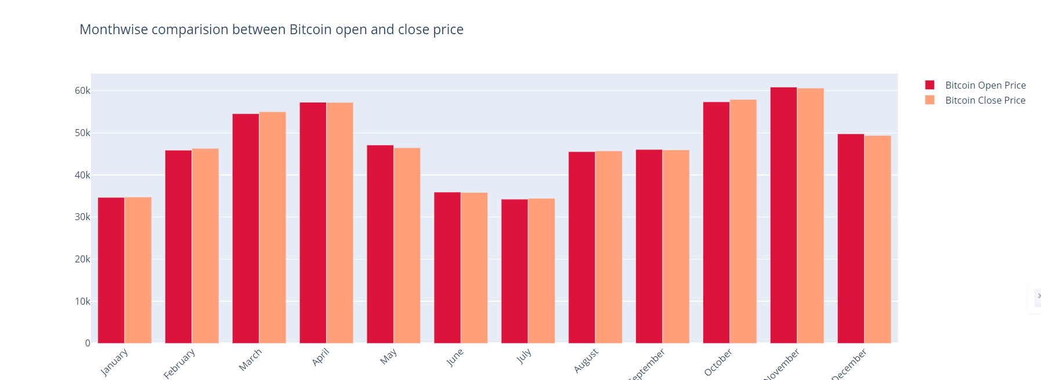

**Fig 23: Month-wise Bitcoin open and close prices for 2021**

**Fig-24: Month-wise Bitcoin High and Low prices for 2021**

**Fig-25: Bitcoin Analysis Chart for 2021**

**Fig 26: Month-wise Bitcoin open and close prices for 2022**

**Fig-27: Month-wise Bitcoin High and Low prices for 2022**

**Fig-28: Bitcoin Analysis Chart for 2022**

**Fig-29: Month-wise Bitcoin open and close prices for 2023**

**Fig-30: Month-wise Bitcoin High and Low prices for 2023**

**Fig-31: Bitcoin Analysis Chart for 2023**

**Fig 32: Month-wise Bitcoin open and close prices for 2024**

**Fig-33: Month-wise Bitcoin High and Low prices for 2024**

**Fig-34: Bitcoin Analysis Chart for 2024**

**Fig-35:Bitcoin Analysis Chart for 2014-2024**

**Fig-36: Whole period of timeframe of Bitcoin close price 2014-2024**

**Fig-37: Training and validation loss**

**Fig-38: Comparision between original close price vs predicted close price**

**Fig-39: whole closing Bitcoin price with prediction**

## 10.Support Vector Machines (SVM).

## We expanded on our analysis in our project by adding Support Vector Machine (SVM) as a second predictive model to forecast Bitcoin prices. Following the SVM model's training on historical Bitcoin price data, we produced predictions and used graphical representations to show the outcomes. We demonstrated how well the SVM model predicts cryptocurrency prices by charting the expected values against actual Bitcoin prices over time. This graphical analysis makes it easier to compare SVM predictions with other models that we have previously assessed in our study and provides insights into the accuracy and dependability of SVM predictions. Stakeholders may use this image to better understand how well the SVM captures patterns and swings in Bitcoin prices, which will help them make more informed investment decisions in the ever-changing cryptocurrency market.

**Fig-40 Training and predicting the price using Support Vector Machines (SVM).**

**11.Linear Regression.**

To further our research, we added Linear Regression to our analysis as a second predictive model for estimating Bitcoin prices. We sought to assess the Linear Regression model's ability to capture price patterns over time by using historical Bitcoin price data to train the model and produce forecasts. We were able to evaluate the precision and potency of the Linear Regression model in predicting cryptocurrency prices by comparing the projected values with the actual prices using graphical displays. With the help of this graphical analysis, stakeholders can make well-informed decisions about trading and investing in cryptocurrencies by learning important information about the accuracy of Linear Regression predictions. By means of this implementation, we made a significant contribution to the thorough comprehension of the advantages and disadvantages of several predictive models in the dynamic domain of predicting Bitcoin prices.

**Fig 41** **Training and predicting the price using Linear Regression.**

**12.Random Forest**

We expanded our analysis by adding Random Forest as a second predictive model to forecast Bitcoin prices. Our goal was to assess the Random Forest model's efficacy in capturing and forecasting price patterns by using it to train on historical Bitcoin price data and produce forecasts. By using graphical displays to compare the expected values with the actual prices of Bitcoin, we carefully evaluated the precision and dependability of the Random Forest model in predicting cryptocurrency prices. Through this graphical analysis, stakeholders can gain significant insights into Random Forest's predictive power, enabling them to make informed decisions regarding their cryptocurrency trading and investment pursuits.

**Fig 42 Training and predicting the price using Random Forest.**

## 13.Novelty

We effectively carried out a thorough analysis in our project to predict the price of Bitcoin using deep learning methods, particularly LSTM (Long Short-Term Memory), in contrast to conventional machine learning algorithms (random forest, linear regression, logistic regression, and decision trees). The present study included a number of criteria, including Mean Absolute Error (MAE), Root Mean Squared Error (RMSE), and Mean Absolute Percentage Error (MAPE), to thoroughly assess each model's performance in addition to delving into the turbulent world of cryptocurrency markets. We definitively proved through rigorous testing that LSTM is more predictive than other algorithms, proving its effectiveness in predicting Bitcoin prices. This hybrid method helps stakeholders navigate the complexity of cryptocurrency trading and investment while also adding to the body of knowledge regarding financial forecasting.

To further improve predictive accuracy and robustness, we advise researchers and practitioners to investigate ensemble methods to combine model strengths, integrate novel features and data representations like blockchain transaction volumes or social media sentiment, and adopt alternative deep learning architectures like Temporal Convolutional Networks (TCNs) and attention mechanisms. Furthermore, the field of Bitcoin price prediction could advance by utilizing transfer learning techniques from time series datasets or related financial markets, enhancing model interpretability with SHAP values and attention-based visualization, and putting in place dynamic model updating mechanisms to adjust to shifting market conditions. These strategies would also provide insightful information for cryptocurrency trading and investment decisions.

## 14.Result &Discussion

With train accuracy at 98.85% and test accuracy at 99.27%, the LSTM model continuously exhibits excellent accuracy in both training and testing stages, according to a comparison of model performance measures across different methods. This performs better than other models like Random Forest, Linear Regression, and Support Vector Machine (SVM). For example, SVM performs similarly, with Test accuracy at 99.02% and Train accuracy at 98.85%, whereas Linear Regression performs worse, with Test accuracy at 62.04% and Train accuracy at 61.09%. In a similar vein, Random Forest obtains test accuracy of 98.35% and train accuracy of 97.65%, which is marginally lower than LSTM.

Bar graphs comparing the performance of each method can be used to visually illustrate these accuracy measurements. The accuracies of LSTM and SVM on training and testing datasets are displayed in a bar graph, which amply demonstrates LSTM's superiority over SVM. To further emphasize the notable variations in accuracy between LSTM and other models, distinct bar graphs can be made for LSTM vs. Random Forest and LSTM vs. Linear Regression. When compared to competing algorithms, these visual representations provide as strong proof of LSTM's ability to predict Bitcoin values properly, giving stakeholders practical advice on trading and investment strategies.

**Fig 43: Ensembling Graph Machine Learning vs LSTM Model**

**Table 2: Comparison of Model Performance Metrics: LSTM vs. Support Vector Machine**

|  |  |  |
| --- | --- | --- |
| **Metric** | **LSTM Model** | **Support Vector Machine** |
| **Train** | 0.9885 | 0.9885 |
| **Test** | 0.9927 | 0.9902 |
| **MSE** | 0.9930 | 0.9927 |

**Fig-44: Bar Graph of LSTM Model vs SVM Model**

**Table 3: Comparison of Model Performance Metrics: LSTM vs. Linear Regression**

|  |  |  |
| --- | --- | --- |
| **Metric** | **LSTM Model** | **Linear Regression** |
| **Train** | 0.9885 | 0.6109 |
| **Test** | 0.9927 | 0.6204 |
| **MSE** | 0.9930 | 124926214.16 |

**Fig-45: Bar Graph of LSTM Model vs Linear Regression**

**Table 4: Comparison of Model Performance Metrics: LSTM vs. Random Forest**

|  |  |  |
| --- | --- | --- |
| **Metric** | **LSTM Model** | **Random Forest** |
| **Train** | 0.9885 | 0.9765 |
| **Test** | 0.9927 | 0.9835 |
| **MSE** | 0.9930 | 0.9839 |

**Fig-46: Bar Graph of LSTM Model vs Random Forest**

# 16.Conclusion

In conclusion, LSTM-based methods have emerged as a transformative approach to Bitcoin price forecasting, addressing critical challenges that traditional models struggled to overcome. By leveraging sophisticated machine learning techniques like long short-term memory neural networks, these models excel at capturing complex, nonlinear relationships and dependencies inherent in cryptocurrency markets. This innovation empowers stakeholders with more accurate insights and projections, enhancing decision-making in the face of market volatility and uncertainty. LSTM-based forecasting represents a pivotal advancement in cryptocurrency analysis, offering renewed confidence to investors and analysts navigating the dynamic landscape of digital assets.

LSTM-based methods revolutionize Bitcoin price forecasting by effectively navigating the inherent complexities of cryptocurrency markets. Unlike traditional techniques, LSTM neural networks excel at capturing sequential dependencies and long-term patterns within highly volatile data. They adapt well to the dynamic nature of Bitcoin prices influenced by regulatory changes, investor sentiment, and market dynamics. This advanced modeling approach enhances risk management and decision-making for stakeholders, providing valuable insights into market behavior and trends. LSTM-based forecasting tools contribute to a deeper understanding of cryptocurrency markets, empowering analysts and investors to make informed choices in a rapidly evolving financial landscape characterized by uncertainty and rapid price fluctuations.

# 17.References

[1] Khedr, A. M., Arif, I., P V, P. R., El-Bannany, M., Alhashmi, S. M., & Sreedharan, M. (Year). Cryptocurrency price prediction using traditional statistical and machine-learning techniques: A survey.

[2] Baranidharan, S., Narayanan, R., & Geetha, V. (Year). Predicting Cryptocurrency Prices Model Using a Stacked Sparse Autoencoder and Bayesian Optimization.

[3] Pant, D. R., Neupane, P., Poudel, A., Pokhrel, A. K., & Lama, B. K. (Year). Recurrent neural network based bitcoin price prediction by twitter sentiment analysis.

[4] Sujatha, R., Mareeswari, V., Chatterjee, J. M., Abd Allah, A. M., & Hassanien, A. E. (Year). A Bayesian regularized neural network for analyzing bitcoin trends.

[5] Der Horst, L., Choo, K. K. R., & Le-Khac, N. A. (Year). Process memory investigation of the bitcoin clients electrum and bitcoin core.tle bit of body text

1. **Appendix Code**

